Grace and Holy

Trinity Church

Guide to Our Programs
and
How to Be Involved

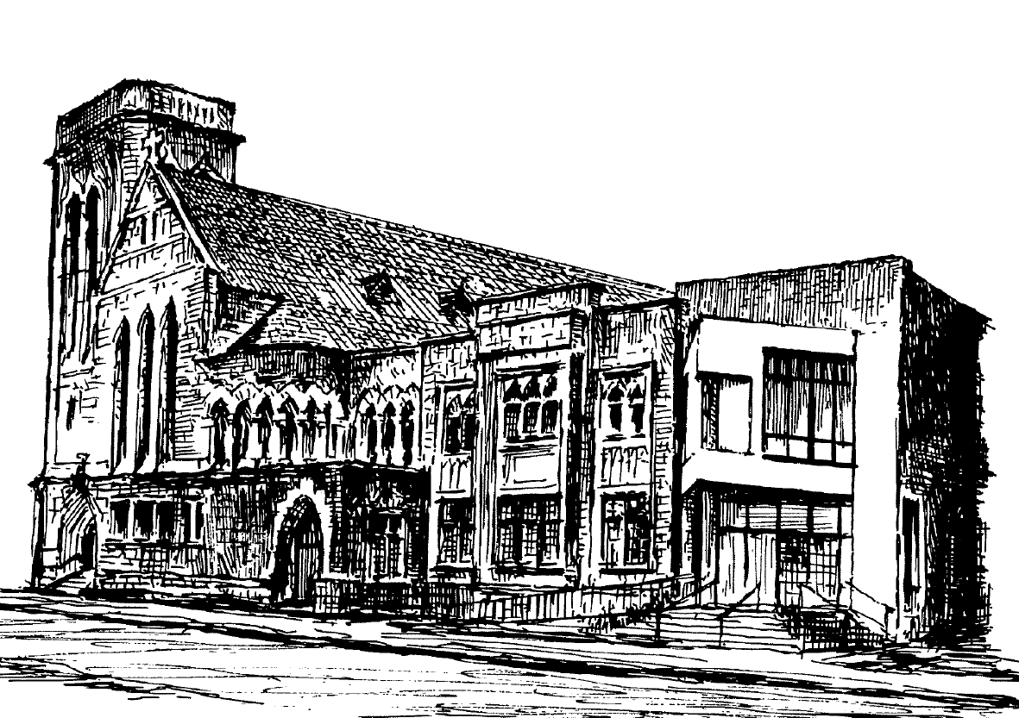

Acolytes | Help serve at the altar during the 8:45 a.m. and 11:00 a.m. services. Acolytes at the 8:45 a.m. service need to be in the 3rd grade and above. Acolytes at the 11:00 a.m. service should be in the 6th grade and above. Contact Dan McNamara or Aaron Davis.
Adult Education – Weekdays  - Weekday Bible and Book Study Groups | Weekday Bible study and book study groups meet at various times and locations each week. Contact Bo Millner.
Adult Education – Sundays  - Adult Forum | Each Sunday, adults are encouraged to join one of our classes for adults. These include the Adult Forum, which is topical and features speakers from the community plus periodic Inquirer’s class and Bible study. Contact Judy Carlson.
Altar Guild Team | Prepares the church and altar for worship services. Contact Dawn McNamara.
Baby Blanket Ministry | Volunteers make and deliver baby blankets for new babies. Contact Bo Millner.
Breakfast Team | Cook, serve and clean-up for Sunday breakfasts. Contact John Thomas or Peter Knecht.
Boomers & Better | For those over 55, this group provides educational and fellowship events including tours, hikes, picnics, and much more. Contact Betsy Featherstone or Beth Melcher Davis.
Bus | The GHTC Bus transports people to and from Westminster-Canterbury on Sundays as needed, transports VCU campus ministry and our youth to events, and more. Contact Barbara Hobson-Simpson for rides and if you’d like to be certified as a driver.
Campus Ministry @ VCU | Grace and Holy Trinity hosts an active Episcopal Campus Ministry group for Virginia Commonwealth University students. Contact Kim Reinholz.
Chalice Bearers | Assist with communion at 8:45 a.m. and 11:00 a.m. Sunday Services. Contact Annette Hook or Bo Millner.
Christmas Ministry | Each year, individuals, families, and ministry groups from the parish ‘adopt’ 25-30 underprivileged families and provide them with gifts and food for the holidays. Contact Kim Reinholz.
Christmas Pageant | Our annual Pageant is a wonderful celebration of the gifts and ministries of our children and many volunteers. It’s easy and fun to participate. Contact Aaron Davis.
Circles RVA | Our newest initiative working to break the cycle of poverty in Richmond. Visit circlesrva.org to learn more. Contact Bill Perkins or Bo Millner.
Columbarium | In recent years, cremation with committal of cremated remains, rather than burial, has become more common. In this way, the remains of the deceased can remain at the church that played such an important part in their lives. Our Columbarium is such a place and is a part of our church’s ongoing ministry to both the living and the dead. Contact Bo Millner.
Endowment Fund | Helps GHTC extend its charitable work and develop ministries. Sara Jo Williams is the President of the Trustees.
eNews | Emailed weekly, this is the perfect way to stay informed. Contact Barb Dodd to suggest information or add your name to the recipient list.
Episcopal Church Women | Meet periodically for fun, fellowship, informative programs and service.  Contact Jodie Pully.
Evangelism (Discipleship) Team | Helps spread the gospel by inviting, welcoming and incorporating people into GHTC. Contact Barb Dodd.
Finance Committee | Develops the operating budget of the Church. Contact Mike Joyce.
Generosity Committee | Develops the human and financial potential of our church. Coordinates the Annual Giving Campaign. Contact Nancy Trego, Marshall Morton or Barb Dodd.
Godly Play | Godly Play is a program of Biblical storytelling for children of all ages. A Godly Play lesson is told each Sunday during the Children’s Sermon portion of the 8:45 a.m. service and a full Godly Play hour takes place at 11:00 a.m. Contact Aaron Davis.
Grants | Each year, the parish provides small grants to various service agencies in the Greater Richmond community. Focus areas for grants are Elder Care, Homelessness and Housing, Food and Basic Needs, Family Crisis, Youth Enrichment and Family Case Management. Contact Kim Reinholz.
Greeters | Welcome people to our Sunday services by being present at the entrances to greet people, answer questions and make people feel welcomed. Contact Barb Dodd.
Lay Eucharistic Visitors | Take communion from the altar at a main Sunday service out to people who cannot be present. The Lay Eucharistic visitors are trained by the clergy and licensed by the Bishop. Contact Bo Millner.
Lectors | Read lessons at all Sunday Morning services. Contact Andrew Peacock for the 7:45 a.m. service or Ann Gray for the 11:00 a.m. services.
Legacy Society | One way to ensure the future of GHTC is through legacy (or planned giving) gifts to GHTC and the endowment fund. Contact Nancy Trego or Brad Davenport.
Money Tellers | Dedicated two-person teams who come to the church once a month on Monday (Tuesday if the bank is closed on Monday) to count the money from the Sunday offering. They count all cash, add up all checks that are in envelopes and make a deposit at the bank. Contact Judy Bowman.
Music | Adult Choir sings weekly at the 11:00 a.m. worship service. They rehearse on Thursday evenings from 7:30 p.m.-9:30 p.m. The Amazing Grace Choir, an intergenerational ensemble of singers and instrumentalists, sings weekly at the 8:45 a.m. worship service. They rehearse on Sunday mornings at 8:00 a.m. The Angels Choir (preK-grade 2) and the Lightshine Choir (grades 3-8) sing every other month at the 8:45 a.m. worship services. They rehearse monthly from 10:45-11:15 a.m. For more information contact Elizabeth Melcher Davis. GHTC’s concert series offers special music for worship services plus the annual Lessons & Carols and spring choral presentation with orchestra.
Nursery | The GHTC nursery is open each Sunday beginning for children up to 4 years old. Nursery care is also provided for various GHTC functions throughout the year. Contact Aaron Davis.
Office Volunteers | Office volunteers are needed to answer the phone and greet visitors during weekly staff meetings (Tuesdays) from 1:30 p.m.-3:30 p.m. or in the afternoons when Barbara is out of the office. Contact Barbara Hobson-Simpson.
Parish Weekend | Grace and Holy Trinity enjoys a weekend retreat at ShrineMont in October of each year. Contact Aaron Davis.
Prayer Group | Members receive a list each week of prayer requests to incorporate in their daily prayers, and make confidential, personal contacts with people on the list, as appropriate. Contact Barbara Hobson-Simpson.
Random Acts of Kindness | Make regular non-intrusive contact (via door step visits or through the mail) with those who are the primary caregivers of loved ones. Contact Nancy Perkins or Bo Millner.
Red Door Ministries including the Soup Kitchen | Our Red Door Ministry includes a clothes closet, prescription assistance, Friday 12:30 p.m. worship, and the Friday Soup Kitchen. New volunteers are always welcome. Contact Molly Howle or Kim Reinholz.
Shawl Ministry | Make prayer shawls to be shared with members and friends in time of need. Contact Betsy Featherstone.
Shining Examples | Meet on Thursday mornings to polish all the brass in the church. Contact Bill DeShazo or Barbara Hobson Simpson.
Social Media | Visit us on Facebook at: www.facebook.com/GraceAndHolyTrinity and be sure to click the “Like” button.
Spirited Sisters | A monthly fellowship group for women of all ages to enjoy dinner at a restaurant with good conversation and food. Contact Cathy Saunders.
Summer Camp at Shrine Mont | There are many summer camping programs available for children, youth and adults at ShrineMont, a conference center of the Diocese of Virginia. Visit www.shrinemontcamps.net or contact Aaron Davis.
Sunday School | Christian formation groups and classes are offered each Sunday for children and teenagers, pre-school through 12th grade, at 10:00 a.m. Contact Aaron Davis.
Tours of the Sanctuary | Tours of the sanctuary are given to visitors touring the Richmond area; specific interest is usually the stained glass windows, with emphasis on the Tiffany window. Contact Barbara Hobson-Simpson.
Ushers | Pass out bulletins and take up the offering. Contact Bill Perkins or Todd Pawson.
Vestry | A 15-member team elected by the congregation; each member serves for three years and also works with one of the Strategic Plan ministries. Contact Darrell Alexander, Senior Warden.
Website | Go to our website at: www.ghtc.org for current news and information.
Welcome Ministry | Deliver a welcome bag to visitors and guests, typically within a day or two of a person’s first visit to GHTC. Contact Barb Dodd.
Worship | There are three worship services each Sunday during the program year, each with its own unique character:  7:45 a.m. Holy Eucharist: Rite I. Traditional spoken word service.  8:45 a.m. Holy Eucharist: Rite II. This service enjoys participation by an intergeneration music team and has a children’s chapel.  11:00 a.m. Holy Eucharist Rite II and once a month Daily Morning Prayer. This service enjoys the participation of our adult choir.  The morning schedule changes during the summer to two services at  7:45 a.m. and 10:00 a.m.
Youth | Active 6th-12th grade students gather for big events (a picnic at the river, Christmas lunch, Lock-in, and Kings Dominion Trip), smaller events (different activities at the church) and community service projects. Youth also go on retreats to ShrineMont with other youth from around the Diocese. Contact Paul Evans and Aaron Davis.
20s-30s | Young Adults get together for fellowship and food. Contact Nick Sollog, Lee Drummond or Thomas Ewers.

To learn more about each of these ministries visit us:
Grace and Holy Trinity Church
8 North Laurel Street
Richmond, VA 23220
804-359-5628

Visit us on Facebook at GraceandHolyTrinity or online at www. ghtc.org

